Title: Food quality and safety: An alarming concern from farm to fork

Dr. Nitika Thakur**1\***

**1\***Assistant Professor (Microbiology)

Shoolini University of Biotechnology and Management Sciences, Solan., HP (India)

Abstract

Food quality and safety are of concern to every individual. The quality of fresh produce is often judged by visual characteristics such as size, shape, color, freedom from blemishes which, it could be argued, are enhanced by pesticide and fungicide applications. Concerns about the possible consequences of using increasing amount of chemical fertilizers have led to a strong interest in alternative strategies to ensure competitive yields and protection of crops. Indiscriminate use of pesticides and herbicides could cause diverse changes in biological balance as well as lead to an increase in the incidence of cancer and other diseases, through the toxic residues present in the edible produce. Up to now, industrialized production methods have clearly shown severe limitations such as a worldwide contamination of the food chain and water by persistent pesticide residues and reduced nutrient and flavor contents through low-cost intensive food production. The present study highlights the increasing trend of pesticides by the farmers to increase the food production and the amount of pesticide that resides in the final produce that reaches a consumer. An alternative survey also focuses on the use of integrating organic practices by the certified organic farmer groups (OFG’s). A parallel analysis has been drawn (GCMS-Fig 1,2 and 3) by comparing the different patterns of cultivation on persistence of pesticides residues which travels through a producer cultivation chain and reaches a food consumption criteria thus, surpassing the set Maximum Residual Limits (MRL).

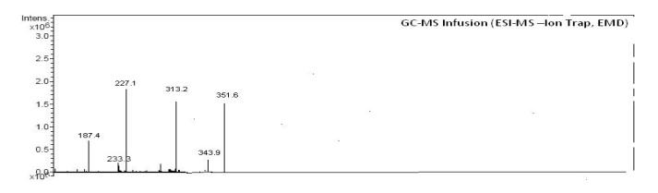

Fig 1: GCMS chromatogram of (Standard) Propergite-SIMBAA (Mol wt. 350.47)

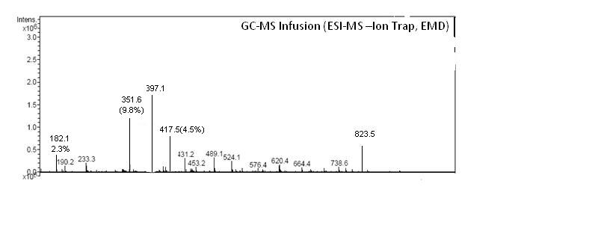

Fig2: GCMS chromatogram of purified organic tomato extract (T₃) for pesticide residue analysis

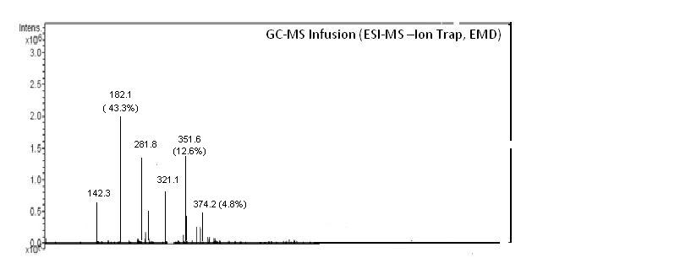

Fig 3: GCMS chromatogram of purified conventional tomato extract for pesticidue residues analysis (T₇ Control)

Key words: Quality; Pesticide; safety; Organic; Conventional; Residues.