Scheduling maize irrigation through crop water stress index (CWSI) in a northern part of Isfahan -Iran
Khadije Fattahiª, Hossein Babazadeh^{b*}, Payam Najafi^{c}, Hossein Sedghi^{d}
ª Department of Water Science and Engineering, Science and Research Branch, Ismaic Azad University, Tehran, Iran
^{b} Department of Water Engineering, Khorasgan Branch, Islamic Azad University. Isfahan, Iran
*Corresponding Author: Department of Water Science and Engineering, College of Agriculture and Natural Resources, Science and Research Branch, Islamic Azad University, End of Sttari Blvd., Tehran, Iran.
Phone: +98-912-699-0105 Email: h_babazadeh@srbiau.ac.ir

Abstract
Qualitative and quantitative restrictions on water resources have given rise to large water stress on land and plants. The recognition of such stresses can be of help in crop management. Due to the large impact on yield, water stress plays an important role in planning proper irrigation, the timing, and amount of water needed by plants. Crop Water Stress Index (CWSI) is one of the key factors for monitoring and quantifying water stress as well as for irrigation scheduling. Maize is the most widely produced crop in the world. This study was conducted in the crop year 2013 for the purpose of Maize (SC-701) irrigation scheduling under climatic conditions of nortern part of Isfahan (i.e., Borkhar) through temperature of leaf, with five irrigation treatments of 35, 65, 75, 85, 100 % Total available water (TAW), in four replications. The results indicated the decline in Total available water from 35 to 100%, and the differences of around 4 ° C in leaf temperature. CWSI increased about three. It is of note that CWSI index in the day before the irrigation for the treatment of T1 to T5 of was about 0.12 to 0.46, respectively. The results revealed that non-stress equation for corn in the treatment T3, was and stress equation was completely fixed and is equal to 2.3. Crop Water Stress Index is based on irrigation planning and it was 0.24. Examining yield results revealed that irrigation scheduling in this area should be done by treatment of 75% Total available water.
Key words: Deficit irrigation, leaf surface temperature, Crop water stress index (CWSI), Soil Water deficit;

- Introduction
Nowadays, the world is facing with increasing population and demand for food as well as shortage of fresh water supplies (Zhang et al., 2016). Deficit irrigation (DI) and urban wastewater utilization are two management solutions for the purpose of reducing fresh water consumption in agriculture. Farmers in northern part of Isfahan employ these strategies due to shortage of irrigation water resources, decline of groundwater level in the area and for the purpose of increasing in the area under cultivation. Precise irrigation planning could be helpful in preventing water stress and optimum performance in plants. Water stress is considered one of the most important plant stresses, which is the most common and limiting factor for yield (Jackson et al., 1981; Scherrer et al., 2011; Zia et al., 2013). The intensity of water stress rides on the time and duration of the irrigation. In view of this, proper methods are needed to classify the water needed by plant in a spatially and temporally manner, and to consider the economic and environmental benefits (Herwitz et al., 2004; Taghvaeian et al., 2013).
Irrigation scheduling methods can be pigeonholed into three categories, namely, the use of water billing, the use of soil profiles, and the use of plant profiles. In this method, water balance is taken into account. Above all, irrigation is usually done when an acceptable amount of available soil water (i.e., readily available water) is used by the plant. Identifying the amount of available soil water for use rides on a variety of factors, such as plant type, physical, and chemical features of the soil. Along these lines, researchers have tried to employ methods that use all the parameters affecting evapotranspiration and water absorption to select a more proper management method. In this regard, the water stress of plants with several indices has been investigated. To compute these indices, it seems necessary to measure the temperature of the leaf surface and air.
Since 1970, Canopy temperature has been accepted as an indicator of water stress because the plants under stress, close their stomata for preserving the water and reducing stomata conduction, decreasing transpiration, and increasing leaf temperature (Ballester et al., 2013; Grant et al., 2006; Idso et al., 1977; Jones, 1999; Leinonen and Jones, 2004; Rodriguez et al., 2005). The relationship between air and canopy temperature has become more variable under water deficits (Mahan et al., 2012; Jackson et al., 1981). In this way, the use of canopy temperature to assess plant growth and development in a limited water context may be more reliable than air temperature alone (Mahan et al., 2014).
Critically, T_{c} can deviate significantly from T_{air} (Siebert et al., 2014; Rezaei et al., 2015). For instance, when soil is wet, as after a rainfall or irrigation, Tc may be several degrees cooler than the air. In opposition, with a dry soil profile, canopies can be several degrees warmer than the air owing to the shrinkage of transpiration rates associated with stomatal closure under water deficit (Clawson et al., 1989; Wall et al., 2006). However, low transpiration rates can also take place when soils are wet, to be precise, when the air-canopy vapor pressure deficit (VPD) is low as it is the case in humid-cool conditions. In addition, weather variables such as amount of incident solar radiation and wind speed (which drives advection) can exert a large direct impact on Tc through the heat balance of the cropped surface (Monteith & Unsworth, 1990), and also indirectly through their influence on crop water use.
One of the most reliable indicators is the crop water stress index (CWSI). Several studies have been conducted on irrigation Scheduling using leaf surface temperature measurements. (Candogan et al., 2013; Orta et al., 2003). The difference in air temperature and leaf area were calculated from the difference in vapor pressure for different irrigation treatments in soybean and watermelon plants. And sorghum in different irrigation systems was studied by O'Shaughnessy et al. (2010) and the crop water stress index (CWSI) was calculated.
Alderfasi and Nielsen (2001) examined the use of water stress index on wheat in Colorado, USA, and concluded that the plant water stress index is a useful tool for evaluating the condition of winter wheat. The water stress index of plants is also employed to identify the irrigation time and evaluation of water status in plants. Zang et al. (2016) examined the water stress index of corn in four stages of plant growth; their results showed that in the third stage of corn growth (i.e., in the flowering stage) the surface temperature of the leaf is higher and the plant uses the most energy for cob growth and thus transpiration from the plant shrinks. Their results indicated that reduced transpiration and water absorption gave rise to an increase in temperature of leaf surface. Mention should be made that in the previous research, the use of the CWSI in irrigation treatments, as well as measuring relative humidity and temperature of the leaf area of the plant is less. Measuring the potential of water in the planting environment due to factors such as root conditions and lack of steam pressure, the presence of water at any potential cannot guarantee the water absorption by the plant. To this end, the use of available water in leaf and leaf surface temperature were considered as an indicator.
According to the aforementioned studies, the this study sought to compute the water stress index (CWSI) of the plant using the Idso method and plotting the lower and upper base line for maize (SC-701) under irrigation treatments in the North climate of Isfahan and use it to identify Irrigation time.

Materials and method
Experiments were carried out in the area of Borkhar, north of Isfahan during the crop year 2013-2012. The area was 32 ° 47 'longitude and 51 ° 45' longitude. The altitude of the area is 1950 m (Fig.1). The climate of this region, like Isfahan, is warm and dry, and the moisture content in the air is 35(%). the maximum evapotranspiration (ET_{O}) is 7 (mm/day) in June. The weather conditions of the area during the growing season of corn are expressed in Table (1). A randomized complete block design along with five irrigation treatments (T1-T5) and four replications was integrated as the design of the study. The treatment and height of irrigation water during the months of June to October are tabulated in Table (2). T1 and T5 treatments have minimum and maximum water intake. The treatments were selected on the basis of the irrigation time and water stress intensity, which both affect the yield of the product. T1, T2, T3, T4 and T5 treatments consisted of 100, 85, 75, 65, and 35% Total Available Water (TAW). Irrigation was done when volumetric moisture content reached the values in each treatment. Different percentages of moisture content were measured by TDR. TDR measures soil moisture at a depth of 35 cm. When the TDR in different plots showed moisture content equal to the amount of water in the desired treatment, irrigation was carried out Fig.3 (a). In tandem, three tensimeters at a depth of 35 cm were installed in three blocks (block 1, 3 & 5) in different parts of the earth and soil moisture was read by them Fig.3 (b). The relationship between the moisture content calculated from the tensiometer and the moisture content was calculated by the equation of Van Genuchten Fig.2.
The area of each experimental block was 25 m², and in each block six rows of maize were planted at a distance of 0.75 m between the rows. The blocks were irrigated via an irrigation system stack. The wheat was harvested, then the blocks were cut. A plumbing system was drawn across the farm surface and each piece was irrigated through a separate valve of diameter 32 mm and the main pipe was connected to a meter and then connected to the major pipe of the farm. Irrigation was manually controlled.
Experimental plant was selected Maize (SC-701). The growth period of corn was 125 days, which was planted on June 27, in the crop year 2013, was harvested on October 29. Some of the physical and chemical features of the sampled soil are displayed in Table (3). The soil from ground to depth (0-30 cm) is clay with pH of 7.3 and EC of 3 dS m⁻¹ and the depth (30-60 cm) is silty clay and with pH of 8.2 and EC 3.5 dS m⁻¹. According to soil testing, it was necessary to have 8 to 10 kg/ha triple phosphate fertilizer (46% phosphorus) manually in each plot at planting time.
Fifty kg ha-1 of ammonium nitrate was fed to the ground with irrigation water. Ammonium nitrate was blended into irrigation water in the first of September first and third with the second irrigation to the field. Cruise herbicide 4 lit/ha on 29 beams and Lasso herbicide at 20 lit/ h on August 26.
When the leaf size reached to a degree that could be used to measure the surface temperature of the leaves, it was done from August 23 to the time of harvesting the plant. Peripheral parameters, including leaf area temperature (TL), measured daily, at a distance of 30 cm from the leaf surface, were measured by an infrared thermometer (Germany's testo 625 model with a precision of 0.1 ° C) Fig.3 (c). The leaf temperature of the leaves in the days before and after irrigation was measured every hour from 8 am to 6 pm via infrared thermometer using four directions of the upper, lower, left and right side of the leaf, and the average was recorded. The temperature of the air (Ta) was measured by a digital thermometer (model Test 625 with 0.5 ° C accuracy) instantaneously Fig.3 (d). Finally, the difference between the temperature of the air and the leaf area (Ta-TL) was also calculated. The digital humidity meter (model Test 625 with 2.5% accuracy) was employed to identify relative humidity (RH) Fig.3 (d). Moisture meter (model Test 625 with 2.5% accuracy). Moisture meter was placed at a distance of 1 to 2 cm from the leaf surface at which the temperature was measured and its relative humidity was identified. The Steam Pressure Deficiency (VPD) of equation (2) was determined after computing the air temperature and relative humidity. Using these data, the regression line was drawn between the difference of the temperature of the leaves and the air as well as the air vapour pressure deficiency. Soil Moisture (SM) was measured by the TDR 100 model (USS Scott Field) and used to estimate it with water potential in the medium using a Tensiometer whose graduation ranged from 0 to -600 in mill bar Fig.3 (a,b).
The water stress index of CWSI plant was based on the linear relationship, during daytime and under homogeneous conditions (daylight or cloudy) between leaf surface temperature and temperature (TL-Ta) and VPD steam shortage for a well-irrigated product with the rate of potential transpiration is (Idso et al., 1981). The shortage of VPD vapor pressure was identified by equation (1), after calculating the air temperature and relative humidity (Monteith & Unsworth, 2013). The difference in temperature between leaf and air was measured by the VPD saturation vapor pressure deficiency of more than 100 W / m2 in the solar radiation. The deficiency of VPD saturation vapor pressure is defined in equation (1).
$$VPD=(1-\left(\frac{RH}{100}\right)×\left(0.6108×{10}^{\left({7.5×Ta}/{237+Ta}\right)}\right)$$ | (1)

Ta: Temperature (° C), RH: Relative humidity (%), VPD: Vapor pressure deficiency (kPa)
The shortage of VPD saturation vapor pressure was used to calculate the NWSB water stress baseline. The bottom line (without water stress NWSB) is a special feature of each plant and represents the conditions in which the plant has no limitations in terms of water supply from the root zone, and evapotranspiration is within the maximum range. AIDS has introduced the lower-tension line as follows (Idso et al., 1982):
$${\left(T_{l}-T_{a}\right)}_{ll}=a-b×VPD$$ | (2)

In this regard, ${\left(T_{l}-T_{a}\right)}_{l.l}$ the difference between the surface temperature of the leaf and the air in the lower base line conditions (° C), a width from the origin and b: the linear gradient. Experimental coefficients of non-stressed basal line were measured using temperature of leaf area in five irrigation treatments Table (2).
The highest water stress line (full stress) is computed irrespective of the vapor pressure shortage and is derived from Equation (3) (Idso et al., 1982).
$${\left(T_{l}-T_{a}\right)}_{ul}=h$$ | (3)
h: constant value in degrees Celsius, (Tl-Ta) _{ul:} difference between the surface temperature of the leaf and the air in the upper base line conditions (° C).
Previous studies suggest that for the empirical determination of the non-stressed baseline and water stress baseline, be used directly from pure radiation, stomata resistance, and micro-climatic conditions of the product, and this is an influential technique for the identification of CWSI (Ballester et al. 2013). The CWSI actual temperature was computed using Equation (4) (Idso et al., 1981; Jackson et al., 1981).
$$CWSI=\frac{{\left(T_{l}-T_{a}\right)}_{m}-{\left(T_{l}-T_{a}\right)}_{ll}}{{\left(T_{l}-T_{a}\right)}_{ul}-{\left(T_{l}-T_{a}\right)}_{ll}}$$ | (4)
(Tl-Ta) m: Leaf and air temperature difference is the day the CWSI target is set for that day.

- Results and discussions
Based on the equations presented in the previous section and the field data, in the days after irrigation, the bases without water stress were calculated in real conditions of the farm Fig. 4, 5.
The regression curve for data was fitted in each treatment and the lower and upper base line equations were tabulated in Table (4). The greatest number of data in the range of 1 to 6 kilopascals is the lack of air vapor pressure.
Days after irrigation with increasing air temperature from morning to evening, with increasing air pressure and increasing evaporation and transpiration, water flow from root to leaf is always maintained and the plant is kept cool. This process continues until the plant can absorb water from the soil. But when the plant cannot absorb soil moisture, it becomes watery and the irrigation time is reached, especially at noon hours, with the increase in the lack of air vapor pressure and the increase in air temperature, the temperature difference between the leaf surface and air decreases and the leaf temperature increases. Base lines based on stress and non-stress conditions for T5 to T1 treatments were used to calculate CWSI. The amount of R² in Fig. 4 and Table 4 shows the correlation between the temperature difference of the air and the leaf area against the difference in vapour pressure. The lowest amount of R² (0.665 and 0.652) was observed in both T1 and T2 treatments. As a result of the decline of water absorption and transpiration, the leaf surface temperature is higher and the difference in leaf and air temperature is positive. The highest amount of R² (0.70 & 0.74) was related to two T4 and T5 treatments, which increased the water absorption and transpiration. As soon as the leaf surface temperature decreased, and the difference between the surfaces temperature of the leaves and the air was negated and the yield of the product increased. The results of Idso et al., 1977, showed that when the plant does not have water deficit, the difference between the plant's green cover (T_{c}) and the temperature (Ta) is negative. When the plant is under intense tension, the difference between the temperature of plant and air green cover somewhat positive.
The data in Table 4 and Fig.4 indicate the position of the upper base lines under each treatment and Fig.5 indicates that with increasing water stress, the upper and lower base lines are displaced. As a result of increasing the stress of irrigation water from T5 to T1, the linear gradient tilt (Tl-Ta) and VPD has fallen below the baseline from +0.2046 to -1.3529. On the other hand, as a result of increasing water stress from T5 to T1, the tensile base line has also risen from 1.3 to 5. Mangus et al. (2016) obtained the water stress base line at different stages of corn growth, equal to 5. Alderfasi and Nielsen (2001) presented the low-level wheat line equation at Colorado State University (Collins) (Tc-Ta) _{l.l} = 0.41-1.5 VPD. Mangus et al. (2016) presented the base-line equation as follows. Empirical leaf canopy and air temperature deficit versus VPD during (a) germination and seedling stage (Tc-Ta) _{l.l} = 2.9491-3.3865 VPD, (b) rapid growth stage (Tc-Ta) _{l.l} = 3.5164 -3.3981 VPD, (c) reproductive stage (Tc-Ta) _{l.l} = 4.2097-2.7815 VPD, and (d) Maturity stage (Tc-Ta) _{l.l} = 4.2337-2.7367 VPD.
The results showed that the line equations for the minimum stress of different products are similar in appearance, but the angle and width coefficients are not similar at the source. It is of note that even under different irrigation conditions and different irrigation treatments, a single equation cannot be proposed for a particular plant. Comparing the bottom line of corn in different treatments suggests this discussion. Based on the slope changes of the bottom lines and their relative position, the reduction (Tl-Ta), for increasing the unit VPD in each of the irrigation treatments and the variation in the temperature difference between the leaf and air temperature, can be reduced to a value deficiency of steam pressure. For instance, for the lack of steam pressure of 3 kPa, the variation in leaf and air temperature difference variations was presented in Table 5. Negative numbers indicate that the air temperature is higher than the surface temperature of the leaves, as well as for the reduction of the drainage allowed the humidity rises from 35% to 100% (TAW), the difference in leaf and air temperature is around 4 °C. The (CWSI) was calculated on the basis of the lower and upper base line equations in equation (4), and the value of CWSI was calculated on the day after irrigation under each treatment. The average leaf and air temperature, as well as the CWSI for each treatment and recurrence, are displayed in Table (6). Data from Table 6 disclose that with decreasing soil moisture, surface irrigation temperatures are rising in irrigation treatments, resulting in differences in leaf and air temperature. Because of irrigation at each turn, the irrigation is based on the desired treatment, so the stress produced as a result of shortage of irrigation water increases leaf area temperature and CWSI. According to the results of analysis of variance in Table (8), the effect of experimental treatments on CWSI is discussed in detail below. The results of Table of analysis of variance revealed that irrigation treatments have a significant effect on the CWSI at a one percent probability level. Comparison of CWSI meanings by Duncan test Table (9) for different irrigation treatments showed that there is a significant difference between treatments. By decreasing the acceptable drainage from 37% to 100%, the CWSI increased from 0.07 to 0.44. Irmak et al. (2002) and Greaves and Wang (2017) reported similar observations in CWSI trend in cases of water deficit stress. For irrigation scheduling, the actual stress before irrigation, leaf area temperature changes (each of the treatments under stress) were used. The average leaf and air temperature and CWSI for the days before irrigation in each of the treatments and replicates are displayed in Table (7). According to the results of variance analysis of Table (8), the effect of experimental treatments on CWSI in the days before irrigation is discussed in detail below. The results of analysis of variance show that irrigation treatments have a significant effect on the CWSI at a one percent probability level. Comparison of CWSI meanings by Duncan test (9) for different irrigation treatments showed that there is a significant difference between treatments. As a result of decreasing drainage volumes from 37% to 100%, the CWSI increased from 0.12 to 0.46. the crop water stress index (CWSI) is closely related to extractable water in the root zone, making it an effective parameter for identifying the severity of crop water stress. For the purpose of this study, the following threshold was adopted to indicate the severity of water stress imposed by the irrigation treatments: CWSI values ≤ 0.2 little to no water stress, 0.2 < CWSI values ≤ 0.4 mild to moderate water stress and CWSI > 0.4 severe water stress. The threshold values adopted in the previous studies were appropriate for the severity (Irmak et al., 2000; Candogan et al., 2013).
The results of analysis of variance of yields of irrigation treatments are displayed in Table 10. Results showed that there was no significant difference between yields of T3 to T5 treatments. The results of comparison of yields in irrigation treatments for corn are presented in Table (11). In this research, the highest grain yield was 9.6 ton h⁻¹ for T5 treatment and the lowest grain yield was 7.1 ton h⁻¹ for T1 treatment. Table (11) shows the results of variance analysis for grain yield between treatments and different years, which has a significant difference at 5% probability level Table (10). Corn plant is relatively tolerant in vegetative stage and its handling of water shortage, but the highest losses take place owing to blue stress during flowering period. Plant height was measured at the end of vegetative growth stage. The maximum height of 178 cm, belonging to T5 treatment and the lowest height of 165 cm, went well with T1 treatment. Table (11). The results of analysis of variance showed that the effect of irrigation treatments was not significant at 5% probability level Table (10). Comparison of yield of treatments showed that the best irrigation time needs to be based on T3 treatment, which in addition to maintaining the optimum performance of water saving in irrigation. Also, the water stress index of the plants in the days before irrigation in T1 T4, T3, T2 and T5 treatments was 0.12, 0.21, 0.24, 0.30 and 0.46 respectively. As a result, the best irrigation time is when the CWSI is less than 0.24. Irrigation scheduling based on the equation Idso (1981) states that the maximum stress does not exceed 0.24. To identify the irrigation time, the surface temperature of the leaf is measured at 12 to 15 hours, and then, according to equation 1 to 4, the value of the CWSI is calculated. If the calculated value is greater than 0.24, irrigation should be carried out. These findings bear testimony to those reported by Yazar et al. (1999) who observed that minimal biomass yield reductions occur at a threshold CWSI value of 0.33 or less for maize. Significant reductions in biomass due to crop water stress have also been reported in other studies (e.g., Omidi et al., 2012; Djaman et al., 2013; Greaves and Wang, 2017). The high productivity associated with DI in maize production, as long as water application amount is adequate to keep soil moisture below the stress threshold and irrigation timing cannot impose stress during the critical growth period, can be attributed to the stimulated physiological response of the crop after soil drying episodes leading to compensation or overcompensation in plant growth and grain yield (Yi et al., 2010).

- Conclusions
The decline of air vapour pressure during the growing season varies from 1 to 6.2 atmospheres. The low-base equation in irrigation treatments indicated that with increase of VPD, the difference between leaf surface temperature and air temperature widened. The results of this study showed that reducing irrigation water increased the surface temperature of the leaf, increasing from 35% to 100% TAW, and the leaf surface temperature difference increased to about 4 °. In this study, the CWSI was calculated in the days before irrigation in T1, T2, T3, T4 and T5 treatments, respectively, 0.12, 0.21, 0.24, 0.30 and 0.46, respectively. The results also showed that with soil moisture change from 26 to 36 percent, the CWSI was about 3.5 times higher. Accordingly, the CWSI can be used to plan irrigation. Comparison of yield of treatments showed that the best irrigation time based on T3 treatment and when CWSI is less than 0.24, in addition to maintaining optimum performance of water saving in irrigation. The results also showed that with soil moisture change from 26 to 36 percent, the CWSI was about 3.5 times higher. As a result, the CWSI can be used to plan irrigation. Comparison of yield of treatments showed that the best irrigation time based on T3 treatment and when CWSI is less than 0.24, in addition to maintaining optimum performance of water saving in irrigation.

- Funding
This project was sponsored by Azad University of Science and Research Branch of Tehran and Azad University of Khorasgan, Isfahan, and Fatahi Meat and Fat Farm.
- References
[1] Alderfasi, A. A, and Nielsen D. C. “Use of crop water stress index for monitoring water status and scheduling irrigation in wheat.” Agricultural Water Management 47 (February 2001): 69-75. https://doi.org/10.1016/S0378-3774(00)00096-2.
[2] Ballester, C., Jimenez-Bello, M.A., Castel, J.R., Intrigliolo, D.S. “Usefulness of thermography for plant water stress detection in citrus and persimmon trees.” Agricultural Water Management 168 (15 January 2013): 120–129. https://doi.org/10.1016/j.agrformet.2012.08.005
[3] Candogan, B. N., Shncik, M., Buyukcangaz, H., Demirtas, C., Goksoy, T. A., and Yazgan, S. “Yield, quality and crop water stress index relationships for deficit-irrigated soybean [Glycine max (L.) Merr.] in sub-humid climatic conditions.” Agricultural Water Management 118 (February 2013): 113– 121. https://doi.org/10.1016/j.agwat.2012.11.021
[4] Clawson, K. L., Jackson, R. D., and Pinter, P. J. “Evaluating plant water stress with canopytemperature differences.” Agronomy Journal 81 (Jan 1988): 858–863. doi:10.2134/agronj1989.00021962008100060004x.
[5] Djaman, K., Irmak, S., Rathje, W. R., Martin, D.L. and Eisenhauer, D. E. 2013. “Maize evapotranspiration, yield production functions, biomass, grain yield, harvest index, and yield response factors under full and limited irrigation.” American Society of Agricultural and Biological Engineers 56 (March 2013): 273–293. https://digitalcommon s.unl.edu/ biosysengfacpub.
[6] Grant, O.M., Chaves, M.M., Jones, H.G. “Optimizing thermal imaging as a technique for detecting stomatal closure induced by drought stress under greenhouse conditions.”Physiologia Plantarum 127 (May 2006): 507–518. https://doi.org/10.1111/j.1399-3054.2006.00686.x
[7] Greaves, G.E. and Wang, Y.M. “The effect of water stress on radiation interception, radiation use efficiency and water use efficiency of maize in a tropical climate.” Turkish Journal of Field Crops 22 (2017): 114-125. doi:
10.17557/tjfc.311904

[8] Herwitz, S.R., Johnson, L.F., Dunagan, S. E., Higgins, R.G., Sullivan, D. V., Zheng, J., Lobitz, B. M., Leung, J. G., Gallmeyer, B. A., Aoyagi, M., Slye, R. E., Brass, J. A. “Imaging from an unmanned aerial vehicle: agricultural surveillance and decision support.” Computers and Electronics in Agriculture 44 (July 2004): 49–61. https://doi.org/10.1016/j.compag.2004.02.006.
[9] Idso, S.B., Jackson, R.D., Reginato, R.J. “Remote sensing of crop yields.”Science 196 (April 1977): 19–25. doi: 10.1126/science.196.4285.19.
[10] Idso, S. B., Jackson, R. D., Pinter. P. J., Reginato, R. J. and J. L. Hatfield. “Normalizing the stress degree-day parameter for environmental variability.” Agricultural Meteorology 24 (1981):45-55. https://doi.org/10.1016/0002-1571(81)90032-7.
[11] Idso, S. B., Reginato, R. J. and J.W Radin. “Leaf diffusion resistance and photosynthesis in cotton related to a foliage temperature based plant water stress index.” Agricultural Meteorology 27 (November 1982): 27-34. https://doi.org/10.1016/0002-1571(82)90016-4.
[12] Irmak, A., Batchelor, W.D., Jones, J. W., Irmak, S., Paz, J.O., Beck, H.W., and Egeh, M. “Relationship between plant available soil water and yield for explaining soybean yield variability.” Applied Engineering in Agriculture 18 (2002):471–482. doi: 10.13031/2013.8748.
[13] Irmak, S., D.Z. Haman and R. Bastug. “Determination of crop water stress index for irrigation timing and yield estimation of corn.” Agronomy Journal 92 (November 1998): 1221–1227. doi:10.2134/agronj2000.9261221x.
[14] Jackson, R.D., Idso, S.B., Reginato, R.J., Pinter Jr., P.J. “Canopy temperature as a drought stress indicator.” Water Resources Research 17(August 1981): 1133–1138. https://doi.org/10.1029/WR017i004p01133.
[15] Jones, H.G. “Use of thermography for quantitative studies of spatial and temporal variation of stomata conductance over leaf surfaces.” Plant, Cell& Environment 22 (January 2002): 1043–1055. https://doi.org/10.1046/j.1365-3040.1999.00468.x.
[16] Leinonen, I., Jones, H.G. “Combining thermal and visible imagery for estimating canopy temperature and identifying plant stress.” Journal of Experimental Botany 55 (June 2004): 1423–1431. https://doi.org/10.1093/jxb/erh146.
[17] Mahan, J.R., Young, A., Payton, P., Bange, M., Stout, J. “Effect of differential irrigation on accumulation of canopy temperature-based heat units in cotton.” Journal Cotton Science 18 (January 2014): 129–136. https://www.researchgate.net/publication/284415252.
[18] Mahan, J.R., Young, A.W., and Payton, P. “Deficit irrigation in a production setting: canopy temperature as an adjunct to ET estimates.” Irrigation Science 30 (March 2012): 127–137. http://dx.doi.org/10.1007/s00271-011-0269-1.
[19] Mangus, D.L., Sharda, A., Zhang, N. “Development and evaluation of thermal infrared imaging system for high spatial and temporal resolution crop water stress monitoring of corn within a greenhouse.” Computers and Electronics in Agriculture 121(February 2016): 149–159. https://doi.org/10.1016/j.compag.2015.12.007.
[20] John L. Monteith and Mike H. Unsworth. “Principles of Environmental Physics.” (1990) Edward Arnold, London.
[21] John L. Monteith and Mike H. Unsworth. “Principles of Environmental Physics: Plants, Animals, and the Atmosphere, fourth Edition.”( 2013) Elsevier Ltd, Oxford, UK. https://doi.org/10.1016/B978-0-12-386910-4.00019-6.
[22] Omidi, A.H., Khazaei, H., Monneveux, P. and F. Stoddard. “Effect of cultivar and water regime on yield and yield components in safflower (Carthamus tinctorius L.).”Turkish Journal of Field Crops 17(2012):10–15. http://www.field-crops.org/assets/pdf/product512cbe038c930.
[23] Orta, A. H., Erdem, Y. and Erdem, T. “Crop water stress index for Watermelon.” Scientia Horticulture 98(April 2003): 121-130. https://doi.org/10.1016/S0304-4238(02)00215-7.
[24] Rezaei, E.E., Webber, H., Gaiser, T., Naab, J., and Ewert, F. “Heat stress in cereals: Mechanisms and modelling. ”European Journal of Agronomy 64 (March 2015): 98–113. https://doi.org/10.1016/j.eja.2014.10.003.
[25] Siebert, S., Ewert, F., Rezaei, E.E., Kage, H., Graß, R. “Impact of heat stress on crop yield—on the importance of considering canopy temperature.” Environmental Research Letters 9 (May 2014): 044012. http://iopscience.iop.org/article/10.1088/1748-9326/9/4/044012/meta.
[26] Wall, G., Garcia, R., Kimball, B., Hunsaker, D., Pinter, P., Long, S., Osborne, C., Hendrix, D., Wechsung, F., Wechsung, G. “Interactive effects of elevated carbon dioxide and drought on wheat.” Agronomy Journal 98(Mar 2006): 354–381. doi: 10.2134/agronj2004.0089.
[27] Yazar, A., A.T. Howell, A.D. Dusek and S.K. Copeland. “Evaluation of crop water stress index for LEPA irrigated corn.”Irrigation Science 18 (May 1999): 171–180. https://link.springer.com/article/10.1007/s002710050059.
[28] Yi, L., Y. Shenjiao, L. Shiqing, C. Xinping and C. Fang. “Growth and development of maize (Zea mays L.) In response to different field water management practices: Resource capture and use efficiency.” Agricultural and Forest Meteorology 150 (April 2010): 606–613. https://doi.org/10.1016/j.agrformet.2010.02.003

Table 1. Weather during the maize growing periods in 2013
Month (Year) | Rainfall (mm) | Temperature (ºC) |  | Relative Moisture (%)
 |  | Maximum | Minimum | Maximum | Minimum
Jun, 2013 | 0.0 | 40.0 | 11.8 | 34.0 | 3.0
July 2013 | 0.0 | 41.1 | 11.8 | 43.0 | 3.0
August 2013 | 0.0 | 36.5 | 8.8 | 41.0 | 3.0
September 2013 | 0.0 | 33.0 | 3.0 | 81.0 | 5.0

Table 2. Date and depth of irrigation water (mm) for different irrigation treatments (T1-T5) in 2013
year | treatment | Jun | July | August | September | October | Total
2013 | T1 | 105 | 180 | 315 | 70 | 0 | 670
 | T2 | 105 | 180 | 315 | 70 | 70 | 740
 | T3 | 105 | 180 | 315 | 140 | 70 | 810
 | T4 | 105 | 180 | 385 | 140 | 70 | 880
 | T5 | 105 | 180 | 385 | 140 | 140 | 950

Table3 .Physical and chemical properties of texted of soil
Depth (cm) | Physical Tests |  |  |  | EC | N | P | k | PH
 | %Clay | %Silt | %Sand | Text. | Ds m-1 | % | Mg/kg  a.v.a | Mg/kg  a.v.a
0-30 | 36 | 46 | 29 | CL | 3.5 | 0.1 | 40 | 423 | 8.2
30-60 | 38 | 46 | 16 | Si.CL | 2.6 | 0.03 | 6.7 | 298 | 8.4

 | Table 4. Estimation of leaf and air temperature difference versus saturated vapor pressure
R2 | Bottom line equation | The base line equation above | treatment
0.66 |  |  | T1
0.65 |  |  | T2
0.67 |  |  | T3
0.70 |  |  | T4
0.74 |  |  | T5

Table 5. Leak and air temperature difference calculated from the equations (Table 4) for steam pressure deficiency 3 kPa
T5 | T4 | T3 | T2 | T1 | treatment
-8 | -7.3 | -6 | -4.9 | -3.7 | Leaf and air temperature difference (Cº)

Table 6. Information needed to calculate CWSI on the day after irrigation under each treatment
Repeat | T5 |  | T4 |  | T3 |  | T2 |  | T1
 | TL-TA | CWSI | TL-TA | CWSI | TL-TA | CWSI | TL-TA | CWSI | TL-TA | CWSI
First Repeat | -11.7 | 0.06 | -10.4 | 0.07 | -5.7 | 0.13 | -3.5 | 0.16 | -2.6 | 0.39
Second Repeat | -11.5 | 0.08 | -10.2 | 0.09 | -5.6 | 0.14 | -3.2 | 0.19 | -2.4 | 0.45
Third Repeat | -11.4 | 0.08 | -10 | 0.10 | -5.5 | 0.15 | -3 | 0.21 | -2.2 | 0.49
fourth Repeat | -11.4 | 0.07 | -10.1 | 0.07 | -5.6 | 0.14 | -3.3 | 0.18 | -2.5 | 0.43
Average | -11.55 | 0.07 | 10.2 | 0.09 | -5.6 | 0.14 | -3.25 | 0.19 | -2.4 | 0.44

Table 7. Information needed to calculate CWSI on the day before irrigation under each treatment
Repeat | T5 |  | T4 |  | T3 |  | T2 |  | T1
 | TL-TA | CWSI | TL-TA | CWSI | TL-TA | CWSI | TL-TA | CWSI | TL-TA | CWSI
First Repeat | -6.3 | 0.11 | -4.5 | 0.23 | -3.5 | 0.24 | -1 | 0.34 | -0.2 | 0.43
Second Repeat | -6.0 | 0.14 | -4.4 | 0.20 | -3.3 | 0.26 | -1.4 | 0.29 | -0.0 | 0.45
Third Repeat | -6.2 | 0.12 | -4.1 | 0.29 | -3.7 | 0.21 | -0.8 | 0.27 | 1.0 | 0.52
fourth Repeat | -6.1 | 0.13 | -4.2 | 0.22 | -3.4 | 0.25 | -1.1 | 0.30 | 0.16 | 0.47
Average | -6.16 | 0.12 | -4.33 | 0.21 | -3.5 | 0.24 | -1.06 | 0.30 | 0.26 | 0.46

Table 8- Analysis of the variance of the CWSI in the experiment
After irrigation | Before irrigation | d.f. | Sources of changes
Average of squares
CWSI | CWSI
0.07** | 0.049 ** | 4 | soil moisture
0.003** | 0.00 ns | 3 | Repeat
0.00 | 0.001 | 9 | Error
ns, ** and *, respectively, are meaningless and meaningful at the probability level of 1 and 5%.

Table 9 - Comparison of CWSI meanings before and after irrigation, using Duncan test
After irrigation | Before irrigation | treatment
CWSI
0.45 d | 0.47d | T1
0.19 c | 0.30c | T2
0.14b | 0.24b | T3
0.09a | 0.21b | T4
0.08a | 0.12a | T5
The meanings of the alphabets do not differ significantly from each other.* Treatments were introduced in the materials and methods.

Table 10. Analysis of variance of yield and grain yield of corn (ANOVA)
Year | Source of |  |  |  |  |  |  |  |  | Mean squares
 | Variation (SOV) |  |  |  | d.f. | Wet yield |  |  |  | Dry yield | plant height | grain yields
2013 | block |  |  |  | 3 | 161.82 |  |  |  | 16.68 | 31.95 | 1.18
 | treatment |  |  |  | 4 | 315.00n.s |  |  |  | 23.05** | 97.18n.s | 4.21*
 | Error |  |  |  | 12 | 50.15 |  |  |  | 6.13 | 54.74 | 1.4
 | cv(coeff var) |  |  |  |  | 8.00 |  |  |  | 9.58 | 4.27 | 13.93
 |  | ** And * are significantly different at 1 and 5% levels, respectively. (ns) No significant differences at the 5% significance level.
Table 11. Average Different treatments in Duncan
Year |  |  | treatment | Wet yield |  |  |  |  | Dry yield |  | plant height |  | grain yields
 |  |  |  | (ton ha-1) |  |  |  |  | (ton ha-1) |  | (cm) |  | (ton ha-1)
2013 |  |  | T1 | 77.8 c |  |  |  |  | 22.0 c |  | 165 ab |  | 7.1 b
 |  |  | T2 | 80.3 bc |  |  |  |  | 25.2 ab |  | 176 ab |  | 7.3 b
 |  |  | T3 | 91.0ab |  |  |  |  | 26.8 a |  | 171 ab |  | 9.2 a
 |  |  | T4 | 97.2 a |  |  |  |  | 28.0 a |  | 171 ab |  | 9.3 a
 |  |  | T5 | 95.8 a |  |  |  |  | 27.4 a |  | 178 a |  | 9.6 a
 |  |  | Avg | 88.4 |  |  |  |  | 25.9 |  | 172 |  | 8.5
 |  | Means with the same letters within a season were not significantly different at the 5% significance level

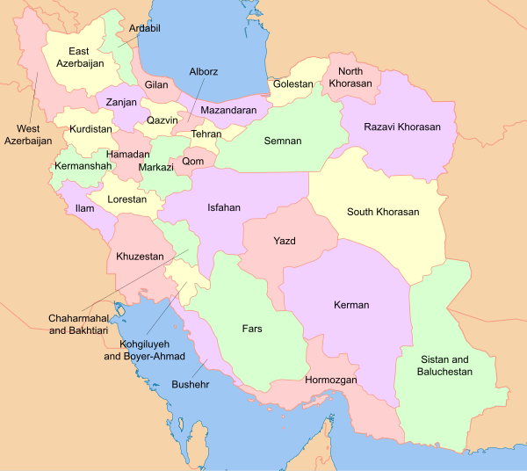
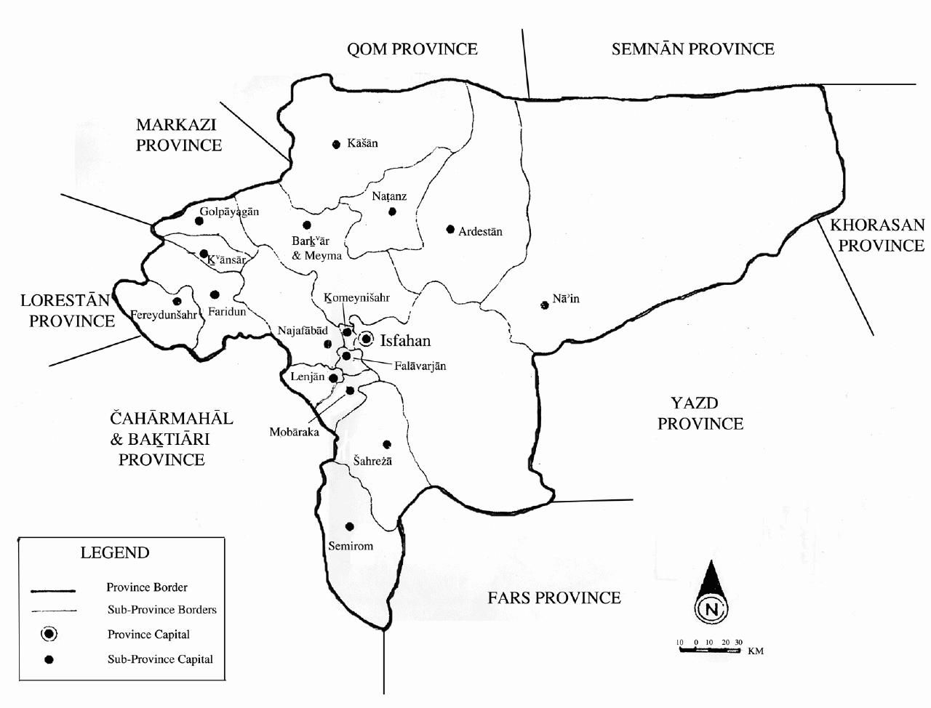

Fig.1. area of study

Fig.2. Relationship between volumetric soil moisture and TDR for calibration
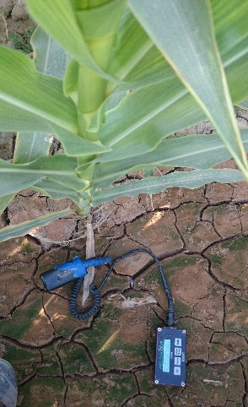  (a) | 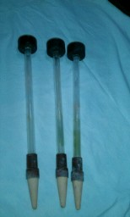  (b) |   (c) | 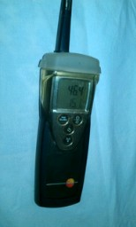  (d)

Fig.3. Measurement devices

(T2) | (T1)
(T4) | (T3)
(T5)

Fig. 4. Position of the upper base lines under each treatment

Fig. 5 - Position of the upper and lower base lines under each treatment
(T: treatment number, U-L: upper base line, L-L: bottom line)

